VISUALIZATION

🔹 Introduction to Data Visualization
Data visualization is the graphical representation of data using charts, graphs, and plots to make patterns, trends, and relationships easier to understand. Instead of analyzing raw numbers in tables, visualization helps users quickly interpret complex datasets and make informed decisions.
Python provides several powerful visualization libraries such as Matplotlib, Seaborn, Plotly, Bokeh, and Pandas plotting tools. In this documentation, we focus on Matplotlib and Seaborn, two of the most widely used libraries for data analysis and exploratory visualization.
🔹 Matplotlib
Overview
Matplotlib is a foundational Python library used for creating static, animated, and interactive visualizations. Developed in the early 2000s, it has become the standard plotting library in the Python ecosystem. Matplotlib offers extensive control over plot elements, making it suitable for highly customized and publication-quality graphics.
It works closely with NumPy and Pandas and supports both procedural (pyplot) and object-oriented plotting styles.
Key Features
- Highly flexible and customizable
- Supports a wide range of plot types
- Suitable for scientific and engineering graphs
- Provides fine control over figure elements
- Works well with numerical Python libraries

Core Components of Matplotlib
• Figure
The figure is the overall container that holds one or more plots. It represents the entire drawing area.
• Axes
Axes are the individual plotting areas within a figure. Each axes object contains the actual chart.
• Axis
Axis objects control tick marks, scaling, and limits of the plot.
• Artists
Artists are all visible elements in a figure such as lines, text, labels, and shapes.
🔹 Common Graph Types in Matplotlib

Line Plot
Description:
A line plot connects data points with straight lines and is mainly used to visualize trends over continuous intervals such as time. 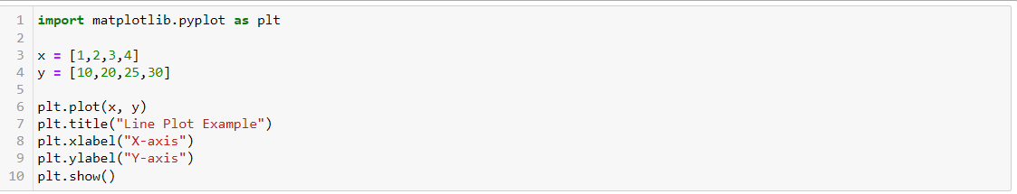
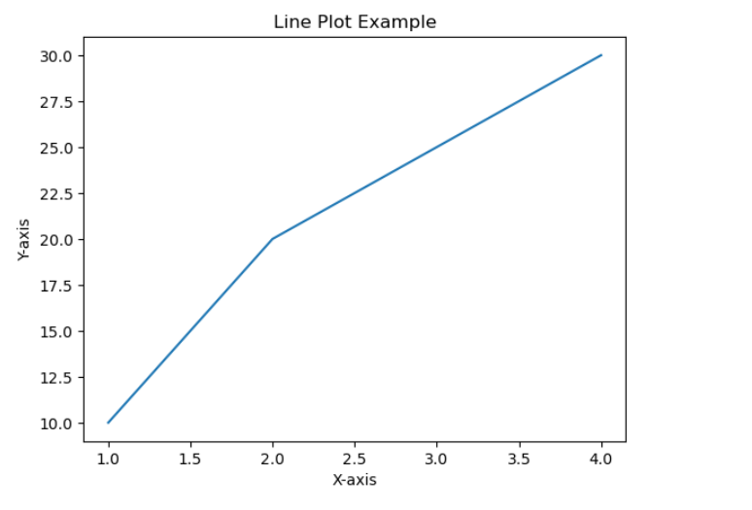
Use Cases:
- Time series analysis
- Stock market trends
- Sensor readings over time
- Performance monitoring
Bar Chart
Description:
Bar charts represent categorical data using rectangular bars whose heights correspond to values.
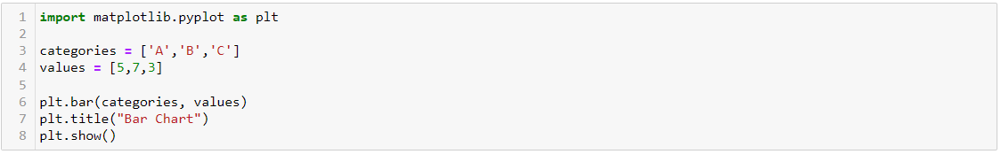
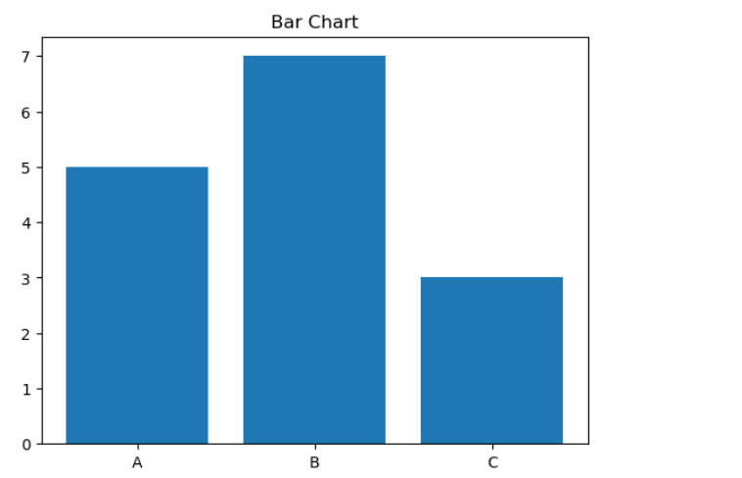
Use Cases:
- Comparing categories
- Sales analysis
- Survey results
- Frequency comparison

Histogram
Description:
A histogram displays the distribution of numerical data by grouping values into bins and showing their frequencies.
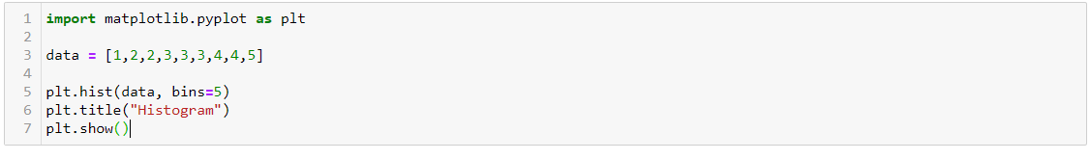
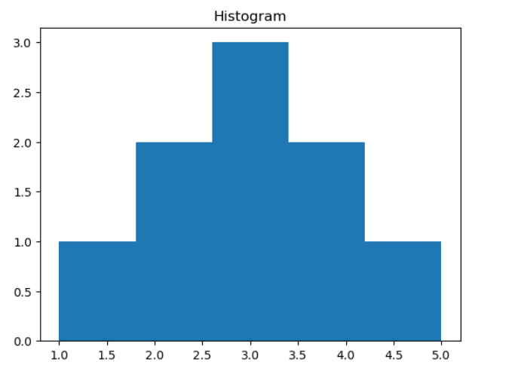
Use Cases:
- Distribution analysis
- Detecting skewness
- Understanding data spread
- Normality checking

Scatter Plot
Description:
A scatter plot shows the relationship between two numerical variables using dots on a coordinate plane.
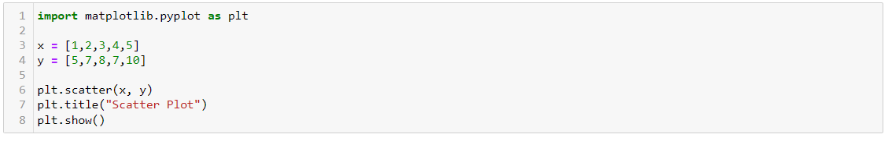
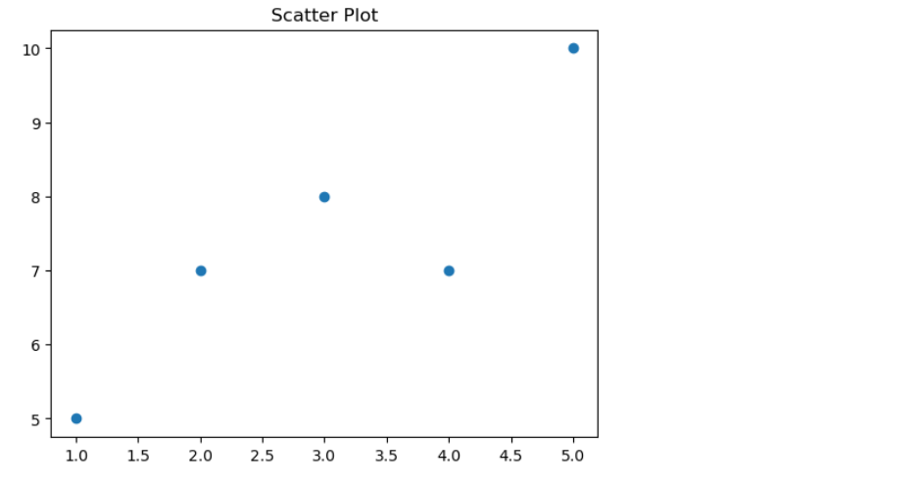
Use Cases:
- Correlation analysis
- Outlier detection
- Relationship between features
- Regression exploration

Pie Chart
Description:
A pie chart represents proportional data as slices of a circle, where each slice indicates a percentage of the whole.
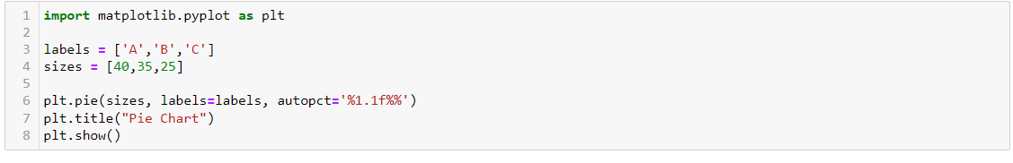
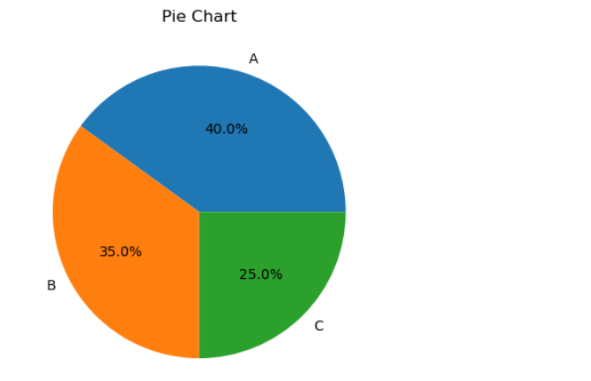
Use Cases:
- Market share distribution
- Budget allocation
- Population composition
- Percentage breakdown

🔹 Seaborn
Overview
Seaborn is a high-level statistical visualization library built on top of Matplotlib. It is designed to make complex visualizations easier to create while producing visually appealing plots by default. Seaborn integrates tightly with Pandas DataFrames and provides built-in themes and color palettes.
It is especially popular in data science workflows for exploratory data analysis.

Key Features
- Attractive default styles
- Simplified syntax
- Built-in statistical visualizations
- Excellent Pandas integration
- Advanced categorical plotting

Categories of Seaborn Plots
Seaborn organizes its visualizations into several functional groups.

🔹 Relational Plots
Used to visualize relationships between variables.
Common plots:
- scatterplot()
- lineplot()
- relplot()
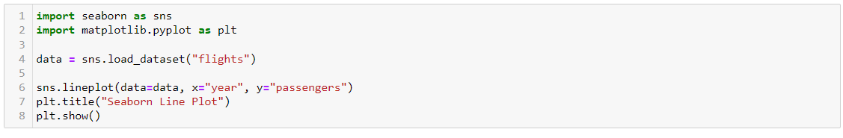
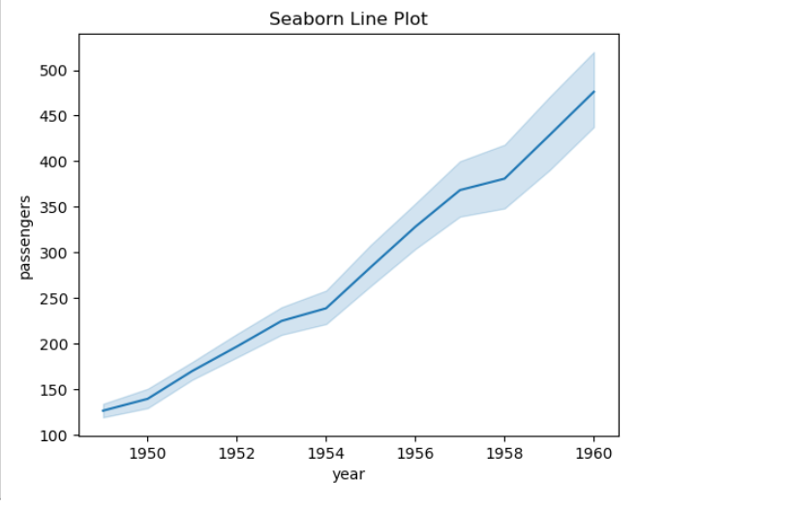
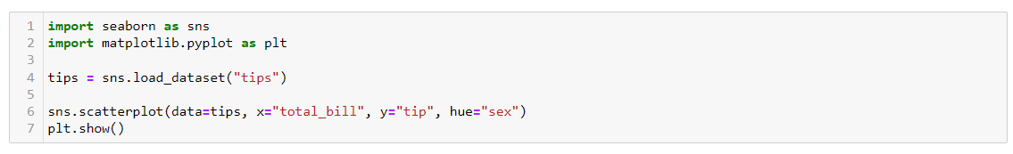
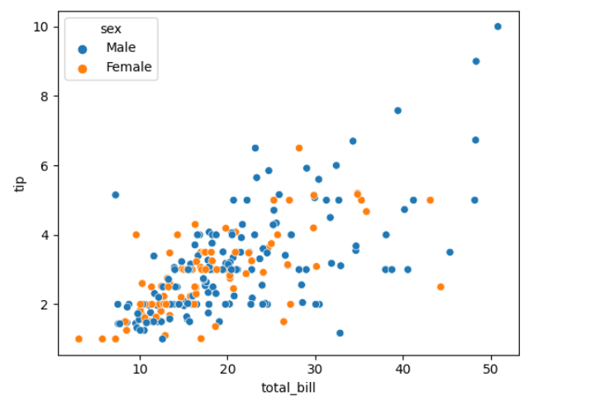
Typical Uses:
- Trend analysis
- Variable relationships
- Time-series visualization

🔹 Categorical Plots
Used when working with categorical data.
Common plots:
- barplot()
- countplot()
- boxplot()
- violinplot()
- swarmplot()
- pointplot()
- catplot()
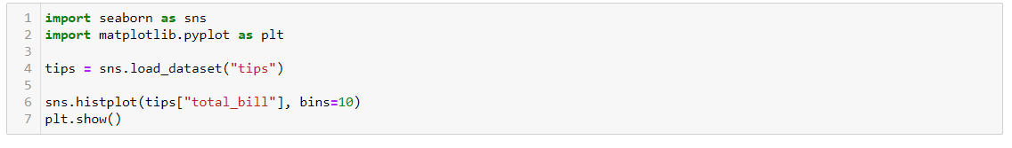
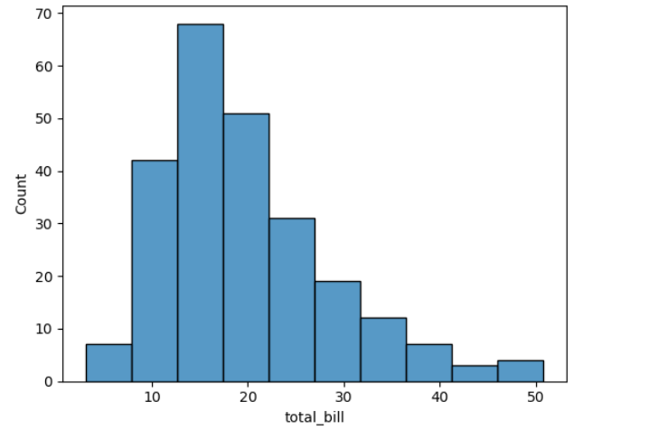
Typical Uses:
- Category comparison
- Distribution across groups
- Outlier detection
- Statistical summaries

🔹 Distribution Plots
Used to understand how data is distributed.
Common plots:
- histplot()
- kdeplot()
- rugplot()
Typical Uses:
- Distribution analysis
- Density estimation
- Data spread visualization

🔹 Regression Plots
Used to visualize relationships along with regression trends.
Common plots:
- regplot()
- lmplot()
Typical Uses:
- Predictive relationship analysis
- Trend modeling
- Correlation with regression line

🔹 Matrix Plots
Used for matrix-style data visualization.
Common plots:
- heatmap()
- clustermap()
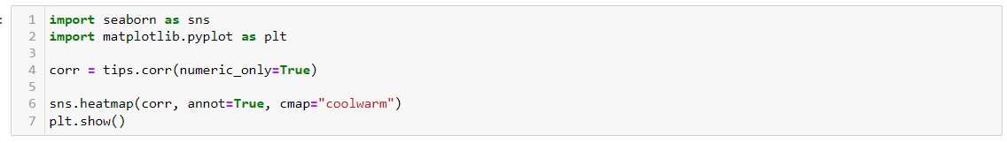
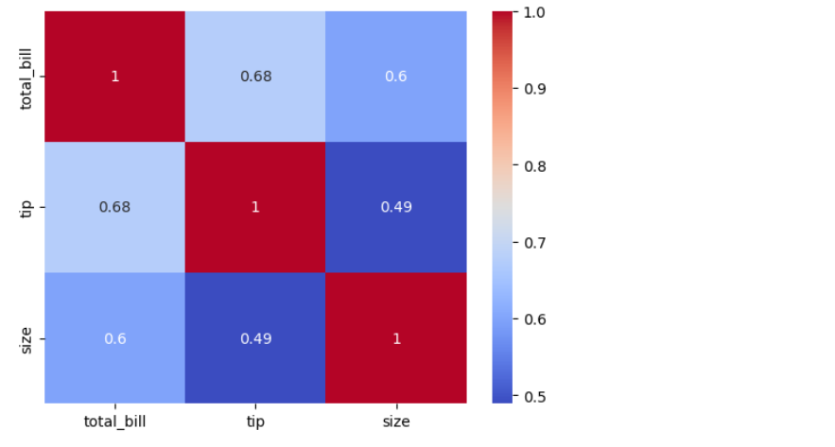
Typical Uses:
- Correlation matrices
- Feature relationships
- Pattern detection in matrices

COMPARISON OF MATPLOTLIB AND SEABORN

Aspect | Matplotlib | Seaborn
Level | Low-level | High-level
Ease of Use | Moderate | Easy
Default Appearance | Basic | Attractive
Customization | Very High | High
Statistical Support | Limited | Strong
Learning Curve | Steeper | Beginner-friendly
Dependency | Independent | Built on Matplotlib

- When to Use Matplotlib
- When full customization is required
- For publication-quality figures
- For complex or non-standard plots
- When working at low level

- When to Use Seaborn
- For quick and beautiful plots
- During exploratory data analysis
- For statistical visualizations
- When working with Pandas data

